What is the PCA Babysitting Co-op?
The Babysitting Co-op is a network of PCA families who exchange free babysitting.
Through an online, points-based system, PCA parents can request and accept specific babysitting times: during the day, at night, or on the weekend.
Unlike a one-on-one babysitting swap, members are not obligated to return sits to a particular member. Parents may fulfill and request sits according to their own schedule with anyone in the Co-op.
The Co-op is perfect for parents who would like to have dependable adults watch their children, meet other families in the community, and save money.
How does it work?

The Co-op works on a point system, where each member family starts out with 40 tokens worth 15 minutes of babysitting per child.
You spend tokens when someone babysits for you, and you earn tokens when you babysit for someone else.
Tokens and contacts are managed through a web service called BabysitterExchange.com.
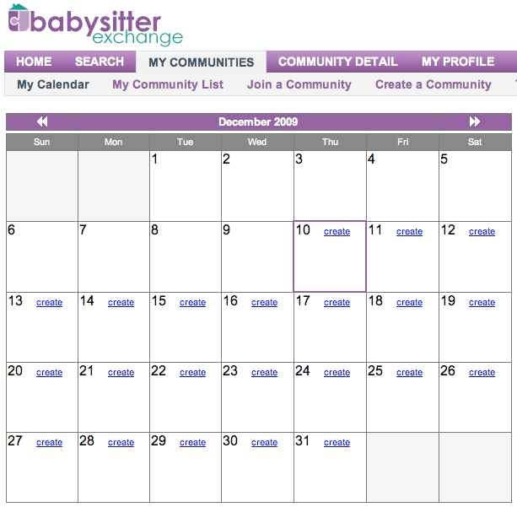
To find a babysitter, you submit a request using the website calendar, and an e-mail is automatically sent to every member. Members submit their availability and you choose who will watch your children.
Any requirements to join?

There are neither fees to join nor requirements to use the service.

We do ask that you attend at least three of our four annual meetings: fun social events the whole family will enjoy.
How do I join?
Send a blank e-mail to [your email here] with “Babysitting Co-op” in the subject line.
We will send you an invitation through our web service BabysitterExchange.com.
Once you complete the very brief enrollment process, feel free to sit back and observe how the Co-op works.
When you’re ready, jump in and make plans to get out on the town!

5 Reasons to Love the PCA Babysitting Co-op
1. Spend less money on childcare, and spend more time on yourself
2. Trade babysitting in a fair system, without having to impose on friends for a favor
3. Relax knowing your children are being cared for by parents in your community
4. Give your children the chance to get to know children from other PAA families
5. Make friends and become part of a supportive social network

Join with a friend today! Contact us at [your email here]

PAA Babysitting
Co-op

Free Childcare by Trusted Parents

To learn more, contact
[your email here]

